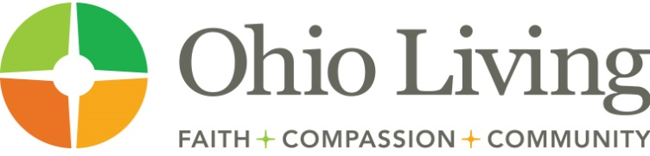

Prospect Development Coordinator
Ohio Living Foundation
Westerville, OH

The Prospect Development Coordinator manages and conducts a full range of donor and prospect research activities to maximize advancement strategies and support Ohio Living Foundation’s fundraising goals.

This position can be remote for someone living outside of the Central Ohio area.

Essential Activities and Tasks

Operations Management
- Conduct research and screening to identify prospective major donors to add to gift officer portfolios; provide individual research upon request.
- Maintain and administer prospect research and management policies and procedures.
- Develop and maintain capacity and affinity ratings.
- Create prospect profile reports.
- Meet regularly with gift officers and support them in strategically managing current and prospective donors, updating solicitation coding, analyzing portfolios, and ensuring proper prospect movement through the donor life cycle.
- Audit meeting notes and interactions entered in Raiser’s Edge.
- Create metrics reports and dashboards to provide analytics support measuring progress toward fundraising goals.
- Assess prospect development program effectiveness and work with leadership to improve processes as needed.

Qualifications

Education
- Bachelor’s degree in a related field required.

Experience
- Three years experience performing prospect research and analysis using various sources of information combined with a demonstrated knowledge and understanding of philanthropy and fundraising practices required.
- Understanding of wealth indicators and ability to translate such information into prospect ratings and gift estimates required.
- Proficiency with Raiser’s Edge or other fundraising system software required.
- Proficiency with Windows, Microsoft Office (Word, Excel, PowerPoint), and the internet required.

To learn more about this exciting opportunity and to apply,
go to www.ohioliving.org/careers.

Please include your cover letter and resume in the same document upload when you apply!

Ohio Living is among the country's leading comprehensive resources on aging well. Our Ohio-based services range from a variety of housing options in one of our life plan communities through the full continuum of care to post-acute home health and hospice support for adults, wherever they live. Ohio Living Foundation raises several million dollars annually to support charity care, special programs, capital expansion and endowment. Most importantly, we’re a company that:
- makes its mission the heart of our organization
- has a reputation for consistently exceeding the needs and expectations of those we serve
- provides an engaging, team-oriented workplace dedicated to career, family and faith
- commits to recognizing our employees for a job well done

We're looking for people who:
- have a passion for helping people, solving problems and contributing to a positive work environment
- are excited about bringing their personal standards and ideals to work each day
- understand that HOW you do your job is just as important as WHAT you do in your job

Why work at Ohio Living?

Depending on an employee’s full-time, part-time or PRN status, they may benefit from:
- competitive wages
- affordable medical, dental, and vision insurance
- 403b retirement savings
- paid time off including your birthday
- training, continuing education, and education assistance
- pay advances up to $500
- the latest technology
- unlimited career opportunities
- and much more!

Who is Ohio Living?

Headquartered in Columbus, Ohio Living is one of the nation's largest not-for-profit, multi-site senior living organizations. Since its founding in 1922, Ohio Living has defined the highest standards of quality of life for adults through its 13 life plan communities and Ohio Living Home Health & Hospice.

Our mission is to provide adults with caring and quality services toward the enhancement of physical, mental and spiritual well-being consistent with the Christian Gospel.

Our Values:
Care * Integrity * Customer Service
Innovation * Financial Stewardship * Leadership

